**IMAGE PROCESSING**

**PROPERTIES OF DFT**

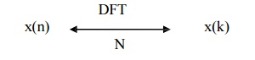

**1.**     **Periodicity**

Let x(n) and x(k) be the DFT pair then if

x(n+N) = x(n)                                                                                     for all n then

X(k+N) = X(k)                                                                                   for all k

Thus periodic sequence xp(n) can be given as



**2.**     **Linearity**

The linearity property states that if

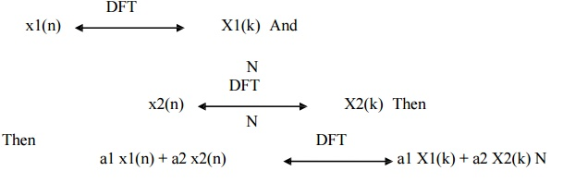

DFT of linear combination of two or more signals is equal to the same linear combination of DFT of individual signals.

**3.**     **Circular Symmetries of a sequence**

 A) A sequence is said to be circularly even if it is symmetric about the point zero on the circle. Thus X(N-n) = x(n)

 B) A sequence is said to be circularly odd if it is anti symmetric about the point zero on the circle. Thus X(N-n) = - x(n)

C) A circularly folded sequence is represented as x((-n))N and given by x((-n))N = x(N-n).

 D) Anticlockwise direction gives delayed sequence and clockwise direction gives advance sequence.

Thus delayed or advances sequence x`(n) is related to x(n) by the circular shift.

**4.**     **Symmetry Property of a sequence**

**A.**    **Symmetry property for real valued x(n) i.e xI(n)=0**

This property states that if x(n) is real then X(N-k) = X*(k)=X(-k)

**B) Real and even sequence x(n) i.e xI(n)=0 & XI(K)=0**

This property states that if the sequence is real and even x(n)= x(N-n) then DFT becomes N-1

**C) Real and odd sequence x(n) i.e xI(n)=0 & XR(K)=0**

This property states that if the sequence is real and odd x(n)=-x(N-n) then DFT becomes N-1

**D) Pure Imaginary x(n) i.e xR(n)=0**

This property states that if the sequence is purely imaginary x(n)=j XI(n) then DFT becomes

**5.**     **Circular Convolution**

The Circular Convolution property states that if

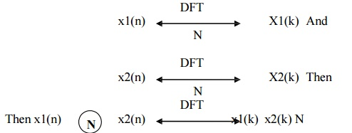

It means that circular convolution of x1(n) & x2(n) is equal to multiplication of their DFT s. Thus circular convolution of two periodic discrete signal with period N is given by

Multiplication of two sequences in time domain is called as Linear convolution while Multiplication of two sequences in frequency domain is called as circular convolution. Results of both are totally different but are related with each other.

**Linear Convolution**

1. In case of convolution two signal sequences input signal x(n) and impulse response h(n) given by the same system, output y(n) is calculated

2. Multiplication of two sequences in time domain is called as Linear convolution

3. Linear Convolution is given by the equation y(n) = x(n) * h(n) & calculated as

4. Linear Convolution of two signals returns N-1 elements where N is sum of elements in both sequences.

**Circular Convolution**

1. Multiplication of two DFT s is called as circular convolution.

2. Multiplication  of  two  sequences in frequency domain is called as circular convolution.

3. Circular Convolution is calculated as

C:\Users\ASUS\Desktop\SJPybJk.jpg

4. Circular convolution returns same number of elements that of two signals.